MUHAMMAD-HAMMAD

LAB-9

**:PRACTICE-TASK QUERIES:**

**QUERY:2**

**QUERY:3**

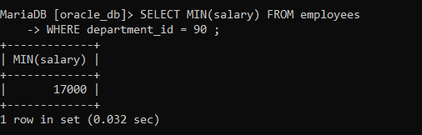

**QUERY:4**

**QUERY:5**

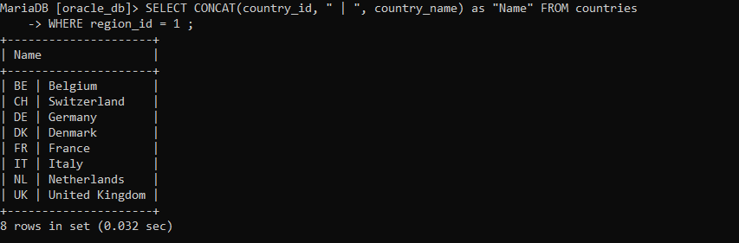

**QUERY:6**

**QUERY:7**

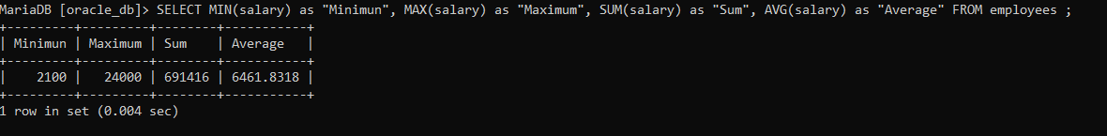

**QUERY:8**

**QUERY:9**

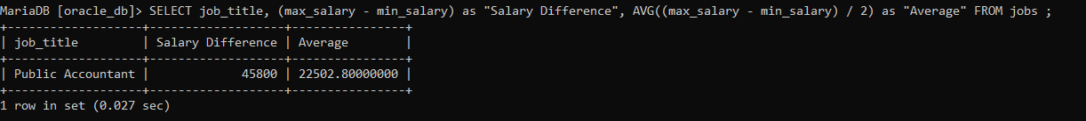

**QUERY:10**

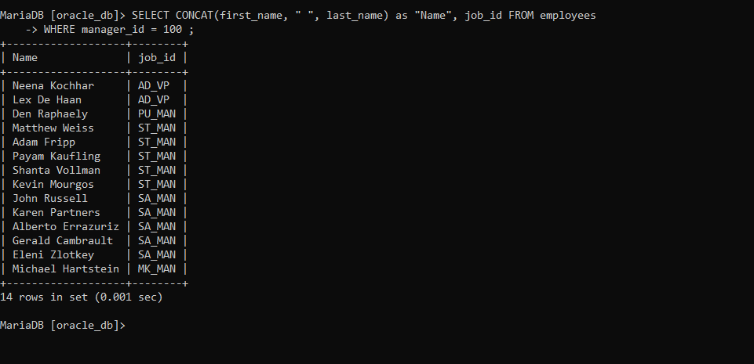

S

----UNSEEN-TASK----

-- 1

CREATE DATABASE BCS213064 ;

USE BCS213064;

-- 2

CREATE TABLE tbl_departments

(

department_id INT(11) NOT NULL PRIMARY KEY,

department_name VARCHAR(30) NOT NULL UNIQUE,

department_manager VARCHAR(100) NOT NULL,

hod_name VARCHAR(100) NOT NULL UNIQUE

) ;

-- 3

ALTER TABLE tbl_departments

MODIFY hod_name VARCHAR(255) NOT NULL UNIQUE ;

-- 4

ALTER TABLE tbl_departments

DROP COLUMN department_manager ;

-- 5

INSERT INTO tbl_departments VALUES

(11, "BBA", "Karen"),

(22, "CS", "Lisa"),

(33, "SE", "Tyler") ;

-- 6

CREATE TABLE tbl_students

(

student_id INT(11) NOT NULL PRIMARY KEY,

student_name VARCHAR(100) NOT NULL,

admission_date Date NOT NULL,

department_id INT(11) NOT NULL,

FOREIGN KEY (department_id) REFERENCES tbl_departments(department_id)

) ;

-- 7

INSERT INTO tbl_students(student_id, student_name, admission_date, department_id) VALUES

(10, "David", "2021-01-06", 22),

(11, "Luis", "2021-04-15", 22),

(12, "Den", "2022-04-10", 33),

(13, "Kevin", "2022-09-08", 11) ;

-- 8

DELETE FROM tbl_students

WHERE student_name = "Luis" ;

-- 9

UPDATE tbl_students

SET department_id = 22

WHERE student_name = "Kevin" ;

-- 10

UPDATE tbl_students

SET admission_date = "2022-04-15"

WHERE student_name = "Den" ;

-- 11

SELECT student_name FROM tbl_students

WHERE student_name NOT LIKE "%d%" ;

-- 12

SELECT student_name, admission_date FROM tbl_students

WHERE student_id BETWEEN 11 AND 13 ;

-- 13

SELECT * FROM tbl_students

ORDER BY student_name DESC ;

-- 14

SELECT * FROM tbl_students

WHERE (student_name LIKE "d%") AND (admission_date LIKE "2022%") ;

-- 15

SELECT student_name FROM tbl_students

WHERE admission_date BETWEEN (admission_date LIKE "____-01-__") AND (admission_date LIKE "____-06-__") ;